Assignment No:2
Name- Chaitali Sawant
PRN- 202501100087
DIV- SE1
Batch- S15

Topic- Sales Dataset

Problem Statement:
A dataset representing sales transactions is provided. It contains Order ID, Product, Category, Region, Sales Rep, Month, Year, Quantity, Unit Price, Discount%, Sales Amount, Profit, Returns, and Customer Rating. The objective is to perform data analysis and manipulation using Pandas and NumPy in Python.

Dataset Creation & Preview

import numpy as np
import pandas as pd

np.random.seed(0)
products = ["Laptop","Smartphone","Tablet","Headphones","Smartwatch",
"Camera","Printer","Monitor","Keyboard","Mouse"]
regions = ["North","South","East","West"]

n = 300
qty_arr = np.random.randint(1, 50, n)
discount_arr = np.round(np.random.uniform(0, 0.3, n), 2)
sales_arr = np.round(price_arr * qty_arr * (1 - discount_arr), 2)
# Inject NaN into Sales_Amount and Profit
sales_arr[np.random.choice(n, 8, replace=False)] = np.nan

df = pd.DataFrame({
"Order_ID" : [f"ORD{1000+i}" for i in range(n)],
"Product" : prod_arr,
"Category" : category_arr,
"Region" : np.random.choice(regions, n),
"Sales_Amount" : sales_arr,
"Profit" : profit_arr,
"Customer_Rating": np.round(np.random.uniform(1,5,n),1),
...
})
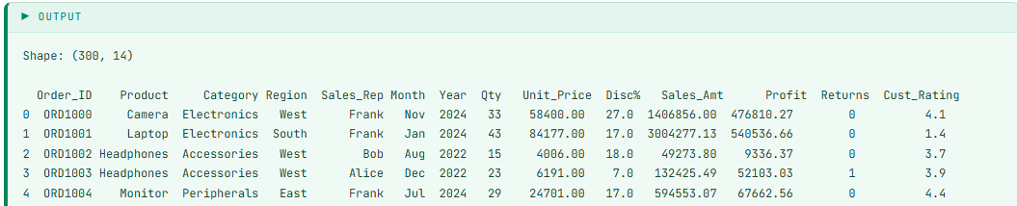

01 Find total number of records and features, and display all column names.
r, c = df.shape
print(f"Rows : {r}")
print(f"Columns : {c}")
print(f"NumPy numeric array shape: {df.select_dtypes(include=np.number).values.shape}")
print(f"Column names: {list(df.columns)}")
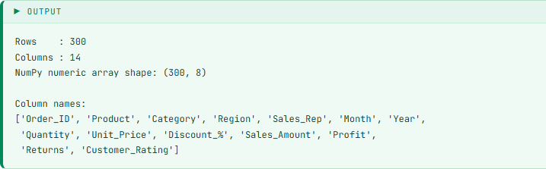

02
Calculate total, average, minimum, and maximum Sales Amount.
sa = df["Sales_Amount"].dropna().values
print(f"Total Sales : ₹{np.sum(sa):>15,.2f}")
print(f"Average Sales: ₹{np.mean(sa):>15,.2f}")
print(f"Min Sales : ₹{np.min(sa):>15,.2f}")
print(f"Max Sales : ₹{np.max(sa):>15,.2f}")
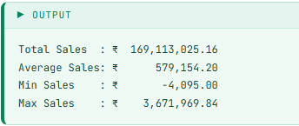
03
Identify and count missing values in each column of the dataset.
mv = df.isnull().sum()
print(mv[mv > 0].to_string())
print(f"\nTotal missing cells: {mv.sum()}")
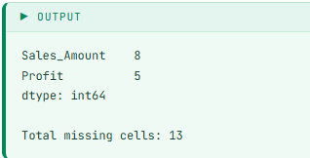

04
Find the product with the highest total sales amount.
ps = df.groupby("Product")["Sales_Amount"].sum().sort_values(ascending=False)
print(ps.apply(lambda x: f"₹{x:,.2f}").to_string())
print(f"\nBest Product: {ps.idxmax()} → ₹{ps.max():,.2f}")
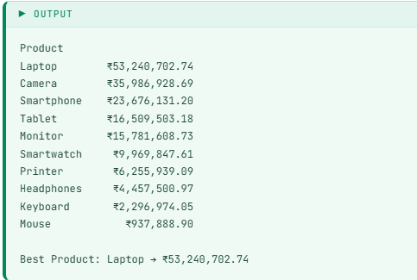

05 Compute total profit per region and identify the most profitable region.
rp = df.groupby("Region")["Profit"].sum().sort_values(ascending=False)
print(rp.apply(lambda x: f"₹{x:,.2f}").to_string())
print(f"\nMost Profitable Region: {rp.idxmax()} → ₹{rp.max():,.2f}")
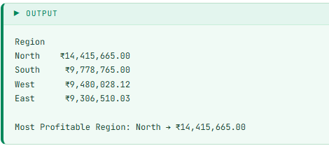

06 Calculate standard deviation and variance of Quantity sold.
q = df["Quantity"].values
print(f"Std Dev (NumPy) : {np.std(q):.4f}")
print(f"Variance (NumPy) : {np.var(q):.4f}")
print(f"Std Dev (Pandas): {df['Quantity'].std():.4f}")
print(f"Variance (Pandas): {df['Quantity'].var():.4f}")
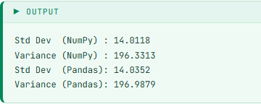

07 Add a new column 'Profit_Margin_%' = (Profit / Sales_Amount) × 100.
df["Profit_Margin_%"] = (df["Profit"] / df["Sales_Amount"] * 100).round(2)
print(df[["Product","Sales_Amount","Profit","Profit_Margin_%"]].dropna().head(10))
print(f"\nAvg Profit Margin: {df['Profit_Margin_%'].mean():.2f}%")

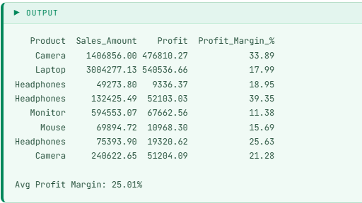

08 Classify sales orders as 'High', 'Medium', or 'Low' using pd.cut().
df["Sales_Category"] = pd.cut(df["Sales_Amount"],
bins=[0, 500000, 1500000, df["Sales_Amount"].max()+1],
labels=["Low", "Medium", "High"])
print(df["Sales_Category"].value_counts())
print(df[["Product","Sales_Amount","Sales_Category"]].dropna().head(8))
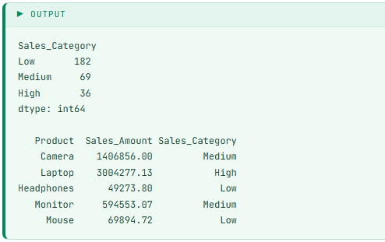

09 Find the top 3 Sales Representatives by total sales amount.
sr = df.groupby("Sales_Rep")["Sales_Amount"].sum().sort_values(ascending=False)
print(sr.apply(lambda x: f"₹{x:,.2f}").to_string())
print(f"\nTop 3 Reps: {list(sr.head(3).index)}")
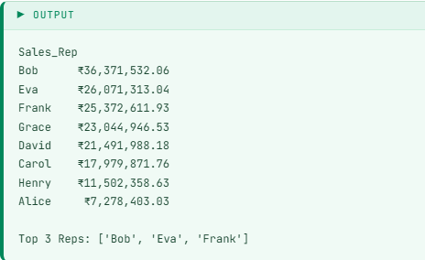

10 Compute 25th, 50th, and 75th percentile of Sales Amount using NumPy.
sv = df["Sales_Amount"].dropna().values
p25, p50, p75 = np.percentile(sv, [25, 50, 75])
print(f"Q1 (25th): ₹{p25:>12,.2f}")
print(f"Q2 (50th): ₹{p50:>12,.2f}")
print(f"Q3 (75th): ₹{p75:>12,.2f}")
print(f"IQR : ₹{p75-p25:>12,.2f}")

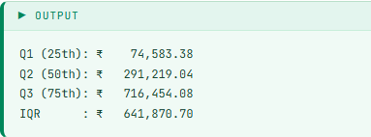

11 Find correlation between Sales Amount, Profit, and Quantity sold.
cc = ["Sales_Amount", "Profit", "Quantity"]
print(df[cc].corr().round(3))
a = df[cc].dropna().values
print(f"NumPy corr(Sales, Profit) : {np.corrcoef(a[:,0], a[:,1])[0,1]:.3f}")
print(f"NumPy corr(Sales, Qty) : {np.corrcoef(a[:,0], a[:,2])[0,1]:.3f}")

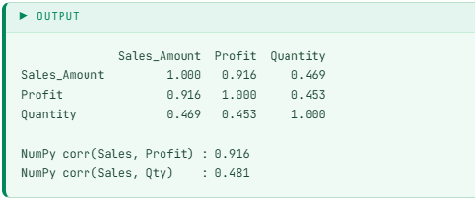

12 Normalize the Sales Amount column to a 0–1 scale using NumPy min-max.
mask = df["Sales_Amount"].notna()
sv2 = df.loc[mask, "Sales_Amount"].values
df.loc[mask, "Sales_Norm"] = ((sv2 - sv2.min()) / (sv2.max() - sv2.min())).round(4)
print(df[["Product", "Sales_Amount", "Sales_Norm"]].dropna().head(10))

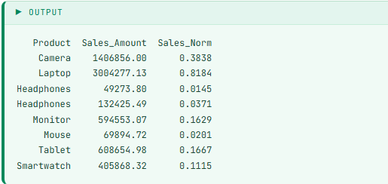

13 Find month-wise total sales and identify the best performing month.
month_order = ["Jan","Feb","Mar","Apr","May","Jun",
"Jul","Aug","Sep","Oct","Nov","Dec"]
ms = df.groupby("Month")["Sales_Amount"].sum().reindex(month_order)
print(ms.apply(lambda x: f"₹{x:,.2f}").to_string())
print(f"\nBest Month: {ms.idxmax()} → ₹{ms.max():,.2f}")

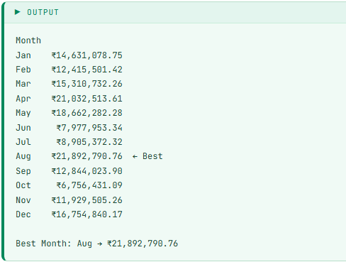

14 Detect outliers in Profit column using the IQR method.
q1 = df["Profit"].quantile(0.25)
q3 = df["Profit"].quantile(0.75)
iqr = q3 - q1
lo, hi = q1 - 1.5*iqr, q3 + 1.5*iqr
out = df[(df["Profit"] < lo) | (df["Profit"] > hi)]
print(f"Q1=₹{q1:,.2f} Q3=₹{q3:,.2f} IQR=₹{iqr:,.2f}")
print(f"Bounds: [₹{lo:,.2f}, ₹{hi:,.2f}]")
print(f"Outlier Count: {len(out)}")
print(out[["Product","Profit"]].head(5))

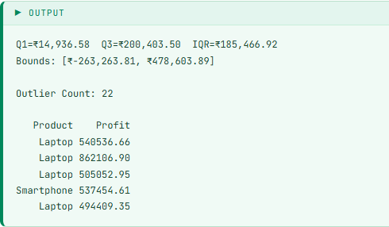
15
Calculate year-wise total sales, average sales, and order count.
ys = df.groupby("Year")["Sales_Amount"].agg(["sum", "mean", "count"]).round(2)
ys.columns = ["Total_Sales", "Avg_Sales", "Orders"]
print(ys.to_string())
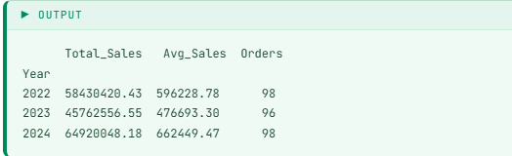

16
Find the percentage of returned orders vs non-returned orders.
ret_pct = df["Returns"].value_counts(normalize=True) * 100
print(f"Returned : {ret_pct[1]:.2f}%")
print(f"Not Returned: {ret_pct[0]:.2f}%")
arr = df["Returns"].values
print(f"NumPy return count: {np.sum(arr)} / {len(arr)}")
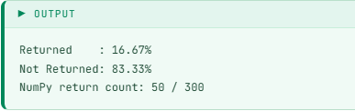
17
Apply log transformation on Sales Amount to reduce right skewness.
sv3 = df["Sales_Amount"].dropna().values
df.loc[df["Sales_Amount"].notna(), "Log_Sales"] = np.log1p(sv3).round(4)
print(f"Original Skewness: {pd.Series(sv3).skew():.4f}")
print(f"Log-Trans Skewness: {df['Log_Sales'].skew():.4f}")
print(df[["Product", "Sales_Amount", "Log_Sales"]].dropna().head(8))
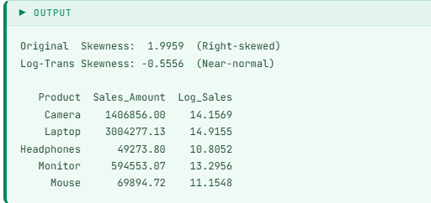

18
Find average, min, and max Customer Rating per product category.
cr = df.groupby("Category")["Customer_Rating"].agg(["mean","min","max"]).round(2)
cr.columns = ["Avg_Rating", "Min_Rating", "Max_Rating"]
print(cr.to_string())
print(f"\nHighest Rated: {cr['Avg_Rating'].idxmax()} → {cr['Avg_Rating'].max():.2f}")
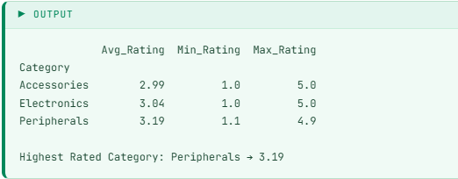

19
Filter high-value orders (Sales > ₹10,00,000) and count by region.
hv = df[df["Sales_Amount"] > 1000000]
print(f"Total High-Value Orders: {len(hv)}")
print("\nRegion-wise count:")
print(hv["Region"].value_counts().to_string())
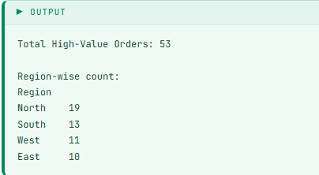

20
Rank products within each category by total profit using Pandas rank().
cat_profit = df.groupby(["Category", "Product"])["Profit"].sum().reset_index()
cat_profit["Rank"] = cat_profit.groupby("Category")["Profit"].rank(
ascending=False, method="dense")
cat_profit = cat_profit.sort_values(["Category", "Rank"])
print(cat_profit.to_string(index=False))
